SoftwareRequirements

# Specification

for

# Personal noter

Version1.0approved

Prepared by: Mr. Ashishkumar Vishwakarma

Mr.Aswad Shaikh

Ms.Mansi Nagrale

M.H Saboo Siddik College of Engineering

<datecreated>

Copyright©1999byKarlE.Wiegers.Permissionisgrantedtouse,modify,anddistributethisdocument.

|  |  |
| --- | --- |
| SoftwareRequirementsSpecificationfor<Project>  TableofContents | Pageii |
| TableofContents | ii |
| RevisionHistory | ii |
| 1.Introduction | 1 |
| 1.1Purpose | 1 |
| 1.2DocumentConventions | 1 |
| 1.3IntendedAudienceandReadingSuggestions | 1 |
| 1.4ProductScope | 1 |

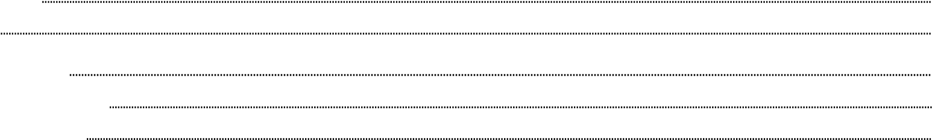1.5References1

2.OverallDescription 2 2.1ProductPerspective 2

2.2ProductFunctions 2

|  |  |
| --- | --- |
| 2.3UserClassesandCharacteristics | 2 |
| 2.4OperatingEnvironment | 2 |
| 2.5DesignandImplementationConstraints | 2 |

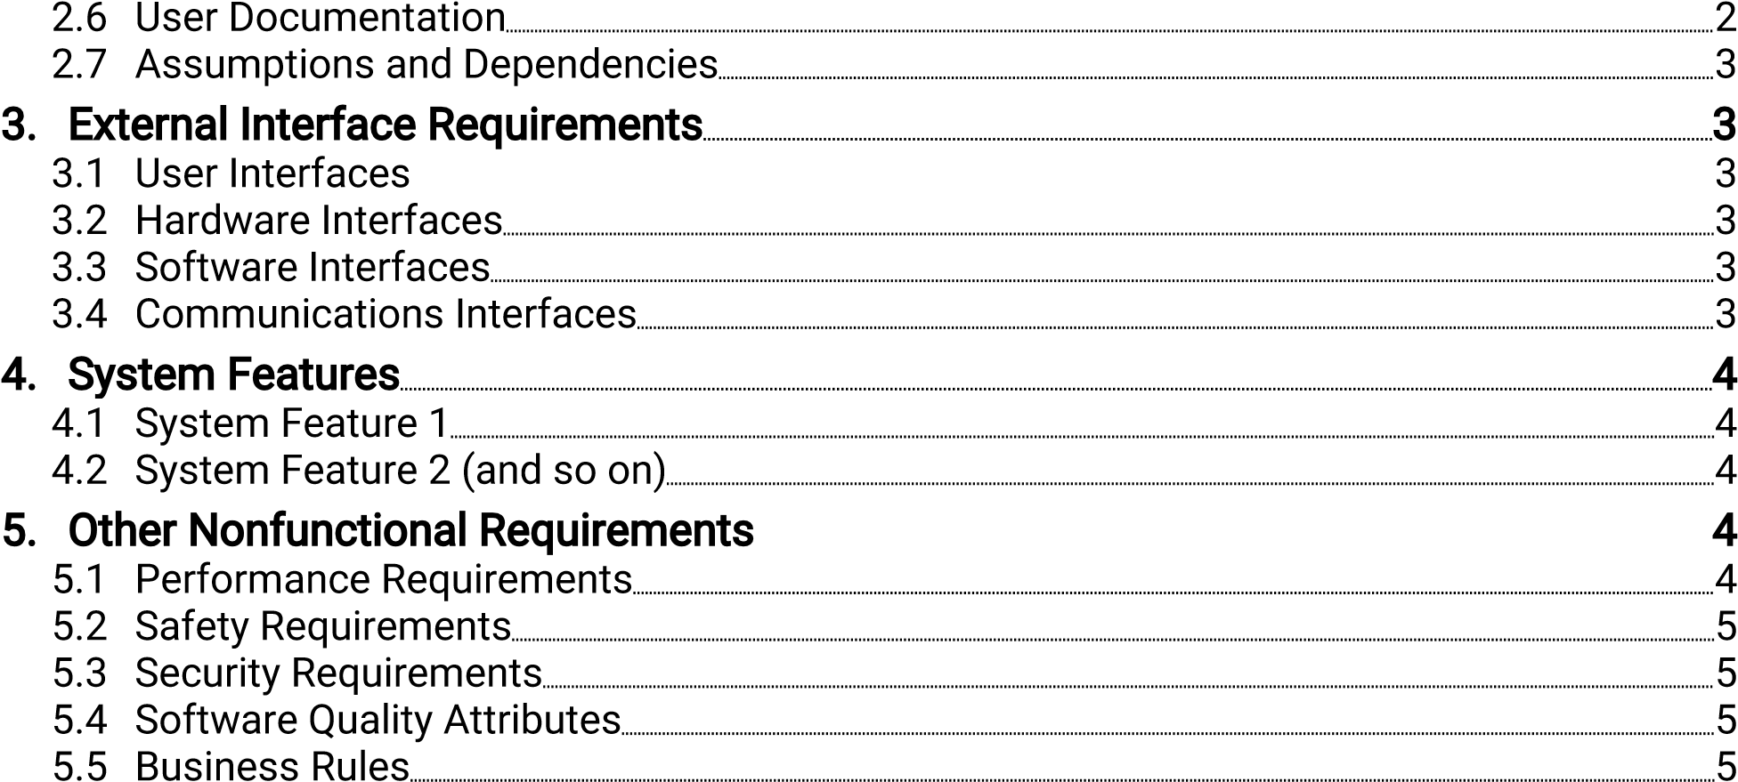

|  |  |
| --- | --- |
| 6.OtherRequirements | 5 |
| AppendixA:Glossary | 5 |
| AppendixB:AnalysisModels | 5 |
| AppendixC:ToBeDeterminedList | 6 |

## RevisionHistory

|  |  |  |  |
| --- | --- | --- | --- |
| Name | Date | ReasonForChanges | Version |
|  |  |  |  |
|  |  |  |  |

SoftwareRequirementsSpecificationfor<Project> Pageiii

## 1.Introduction

This section gives a scope description and overview of everything including the SRS document. Also the purpose for this document is described and a list of abbreviations and definitions are provided.

### Purpose

The purpose of the document is to give a detailed description of the requirement for the website named “**Personal noter**”. It will illustrate the purpose and complete declaration for the development of the system. It will also explain the system constraint, interface and interaction with user and application. This document is primarily intended to be proposed to user for its approval and a reference for developing the first version of the system for the development team.

### Document Conventions

|  |  |  |
| --- | --- | --- |
| **Sr.No** | **Term** | **Defination** |
| 1. | User | Someone who interacts with the website. |
| 2. | Notes | Notes for keeping an update about the subject. |
| 3. | Profile | Complete information about the user of the system. |
| 4. | Laptop/Smartphone | The target device on which the website will be accessible. |
| 5. | System | The proposed system which spans the website. |

### Intended Audience and Reading Suggestions

The document is intended for the software development team, the testers who test for any loopholes or bugs in the system and the design team. These are the people who are involved in the process of the development of this software.

### Product Scope

The system named “Personel Noter” is like Google notes like website for a user which would help the user to effectively maintain the notes for different events. These notes can be accessed from anywhere and any device irrespective of the device is connected to the Ethernet. The website would also notify the user in case of missing an event. Like in google notes which supports saving notes and setting reminders but these functionalities are limited as you would have to buy for the pro version and the customisation is very limited. This website can also be used to upload the important documents which would be a great way to manage those million shabby documents.

### References

* IEEE SRS format document.
* Software Requirement Specification for Google Notes.
* Software Requirement Specification for Document and Storage sites.

## 2. Overall Description

This section will give an overview of the whole system. The system will be explained in its context to show how the system interacts with other systems and introduce the basic functionality of it. It will also describe what type of stackholders that will use the system and what functionality is available for each type. At last, the constraints for the system will be presented.

### 2.1 Product Perspective

“Personel noter” is an independent and a alternative notes managing website. Every person needs a secure and private online space for creating a routine of jobs that need to be done in that whole day or month or even in that whole year. This website can be used for that without any fees and get notified about various events based on their priority. The system is not a part of a larger system, it is an independent system.

The website can also be used manage the document which would come in handy as you can check your notes as well as check your documents at the same place.

### 2.2 ProductFunctions

<Summarizethemajorfunctionstheproductmustperformormustlettheuserperform.Details willbeprovidedinSection3,soonlyahighlevelsummary(suchasabulletlist)isneededhere. OrganizethefunctionstomakethemunderstandabletoanyreaderoftheSRS.Apictureofthe majorgroupsofrelatedrequirementsandhowtheyrelate,suchasatopleveldataflowdiagramor objectclassdiagram,isofteneffective.>

### 2.3 UserClassesandCharacteristics

<Identifythevarioususerclassesthatyouanticipatewillusethisproduct.Userclassesmaybe differentiatedbasedonfrequencyofuse,subsetofproductfunctionsused,technicalexpertise, securityorprivilegelevels,educationallevel,orexperience.Describethepertinentcharacteristics ofeachuserclass.Certainrequirementsmaypertainonlytocertainuserclasses.Distinguishthe mostimportantuserclassesforthisproductfromthosewhoarelessimportanttosatisfy.>

### 2.4 OperatingEnvironment

<Describetheenvironmentinwhichthesoftwarewilloperate,includingthehardwareplatform, operatingsystemandversions,andanyothersoftwarecomponentsorapplicationswithwhichit mustpeacefullycoexist.>

### 2.5 DesignandImplementationConstraints

<Describeanyitemsorissuesthatwilllimittheoptionsavailabletothedevelopers.Thesemight include:corporateorregulatorypolicies;hardwarelimitations(timingrequirements,memory requirements);interfacestootherapplications;specifictechnologies,tools,anddatabasestobe used;paralleloperations;languagerequirements;communicationsprotocols;security considerations;designconventionsorprogrammingstandards(forexample,ifthecustomer’s organizationwillberesponsibleformaintainingthedeliveredsoftware).>

### 2.6 UserDocumentation

<Listtheuserdocumentationcomponents(suchasusermanuals,on-linehelp,andtutorials)that willbedeliveredalongwiththesoftware.Identifyanyknownuserdocumentationdeliveryformats orstandards.>

### 2.7 AssumptionsandDependencies

<Listanyassumedfactors(asopposedtoknownfacts)thatcouldaffecttherequirementsstated intheSRS.Thesecouldincludethird-partyorcommercialcomponentsthatyouplantouse,issues aroundthedevelopmentoroperatingenvironment,orconstraints.Theprojectcouldbeaffectedif theseassumptionsareincorrect,arenotshared,orchange.Alsoidentifyanydependenciesthe projecthasonexternalfactors,suchassoftwarecomponentsthatyouintendtoreusefrom anotherproject,unlesstheyarealreadydocumentedelsewhere(forexample,inthevisionand scopedocumentortheprojectplan).>

## 3.ExternalInterfaceRequirements

### 3.1 UserInterfaces

<Describethelogicalcharacteristicsofeachinterfacebetweenthesoftwareproductandtheusers. Thismayincludesamplescreenimages,anyGUIstandardsorproductfamilystyleguidesthatare tobefollowed,screenlayoutconstraints,standardbuttonsandfunctions(e.g.,help)thatwill appearoneveryscreen,keyboardshortcuts,errormessagedisplaystandards,andsoon.Define thesoftwarecomponentsforwhichauserinterfaceisneeded.Detailsoftheuserinterfacedesign shouldbedocumentedinaseparateuserinterfacespecification.>

### 3.2 HardwareInterfaces

<Describethelogicalandphysicalcharacteristicsofeachinterfacebetweenthesoftwareproduct andthehardwarecomponentsofthesystem.Thismayincludethesupporteddevicetypes,the natureofthedataandcontrolinteractionsbetweenthesoftwareandthehardware,and communicationprotocolstobeused.>

### 3.3 SoftwareInterfaces

<Describetheconnectionsbetweenthisproductandotherspecificsoftwarecomponents(name andversion),includingdatabases,operatingsystems,tools,libraries,andintegratedcommercial components.Identifythedataitemsormessagescomingintothesystemandgoingoutand describethepurposeofeach.Describetheservicesneededandthenatureofcommunications. Refertodocumentsthatdescribedetailedapplicationprogramminginterfaceprotocols.Identify datathatwillbesharedacrosssoftwarecomponents.Ifthedatasharingmechanismmustbe implementedinaspecificway(forexample,useofaglobaldataareainamultitaskingoperating system),specifythisasanimplementationconstraint.>

### 3.4 CommunicationsInterfaces

<Describetherequirementsassociatedwithanycommunicationsfunctionsrequiredbythis product,includinge-mail,webbrowser,networkservercommunicationsprotocols,electronic forms,andsoon.Defineanypertinentmessageformatting.Identifyanycommunicationstandards thatwillbeused,suchasFTPorHTTP.Specifyanycommunicationsecurityorencryptionissues, datatransferrates,andsynchronizationmechanisms.>

## 4.SystemFeatures

<Thistemplateillustratesorganizingthefunctionalrequirementsfortheproductbysystem features,themajorservicesprovidedbytheproduct.Youmayprefertoorganizethissectionby usecase,modeofoperation,userclass,objectclass,functionalhierarchy,orcombinationsof these,whatevermakesthemostlogicalsenseforyourproduct.>

### 4.1 SystemFeature1

<Don’treallysay“SystemFeature1.”Statethefeaturenameinjustafewwords.>

#### 4.1.1 DescriptionandPriority

<ProvideashortdescriptionofthefeatureandindicatewhetheritisofHigh,Medium, orLowpriority.Youcouldalsoincludespecificprioritycomponentratings,suchas benefit,penalty,cost,andrisk(eachratedonarelativescalefromalowof1toahigh of9).>

#### 4.1.2 Stimulus/ResponseSequences

<Listthesequencesofuseractionsandsystemresponsesthatstimulatethe behaviordefinedforthisfeature.Thesewillcorrespondtothedialogelements associatedwithusecases.>

#### 4.1.3 FunctionalRequirements

<Itemizethedetailedfunctionalrequirementsassociatedwiththisfeature.Theseare thesoftwarecapabilitiesthatmustbepresentinorderfortheusertocarryoutthe servicesprovidedbythefeature,ortoexecutetheusecase.Includehowtheproduct shouldrespondtoanticipatederrorconditionsorinvalidinputs.Requirementsshould beconcise,complete,unambiguous,verifiable,andnecessary.Use“TBD”asa placeholdertoindicatewhennecessaryinformationisnotyetavailable.>

<Eachrequirementshouldbeuniquelyidentifiedwithasequencenumberora meaningfultagofsomekind.>

REQ-1:

REQ-2:

4.2 SystemFeature2(andsoon)

## 5.OtherNonfunctionalRequirements

### 5.1 PerformanceRequirements

<Ifthereareperformancerequirementsfortheproductundervariouscircumstances,statethem hereandexplaintheirrationale,tohelpthedevelopersunderstandtheintentandmakesuitable designchoices.Specifythetimingrelationshipsforrealtimesystems.Makesuchrequirementsas specificaspossible.Youmayneedtostateperformancerequirementsforindividualfunctional requirementsorfeatures.>

### 5.2 SafetyRequirements

<Specifythoserequirementsthatareconcernedwithpossibleloss,damage,orharmthatcould resultfromtheuseoftheproduct.Defineanysafeguardsoractionsthatmustbetaken,aswellas actionsthatmustbeprevented.Refertoanyexternalpoliciesorregulationsthatstatesafety issuesthataffecttheproduct’sdesignoruse.Defineanysafetycertificationsthatmustbe satisfied.>

### 5.3 SecurityRequirements

<Specifyanyrequirementsregardingsecurityorprivacyissuessurroundinguseoftheproductor protectionofthedatausedorcreatedbytheproduct.Defineanyuseridentityauthentication requirements.Refertoanyexternalpoliciesorregulationscontainingsecurityissuesthataffect theproduct.Defineanysecurityorprivacycertificationsthatmustbesatisfied.>

### 5.4 SoftwareQualityAttributes

<Specifyanyadditionalqualitycharacteristicsfortheproductthatwillbeimportanttoeitherthe customersorthedevelopers.Sometoconsiderare:adaptability,availability,correctness,flexibility, interoperability,maintainability,portability,reliability,reusability,robustness,testability,and usability.Writethesetobespecific,quantitative,andverifiablewhenpossible.Attheleast,clarify therelativepreferencesforvariousattributes,suchaseaseofuseovereaseoflearning.>

### 5.5 BusinessRules

<Listanyoperatingprinciplesabouttheproduct,suchaswhichindividualsorrolescanperform whichfunctionsunderspecificcircumstances.Thesearenotfunctionalrequirementsin themselves,buttheymayimplycertainfunctionalrequirementstoenforcetherules.>

## 6.OtherRequirements

<DefineanyotherrequirementsnotcoveredelsewhereintheSRS.Thismightincludedatabase requirements,internationalizationrequirements,legalrequirements,reuseobjectivesforthe project,andsoon.Addanynewsectionsthatarepertinenttotheproject.>

## AppendixA:Glossary

<DefineallthetermsnecessarytoproperlyinterprettheSRS,includingacronymsand abbreviations.Youmaywishtobuildaseparateglossarythatspansmultipleprojectsortheentire

organization,andjustincludetermsspecifictoasingleprojectineachSRS.>

## AppendixB:AnalysisModels

<Optionally,includeanypertinentanalysismodels,suchasdataflowdiagrams,classdiagrams, state-transitiondiagrams,orentity-relationshipdiagrams.>

## AppendixC:ToBeDeterminedList

<CollectanumberedlistoftheTBD(tobedetermined)referencesthatremainintheSRSsothey canbetrackedtoclosure.>